L09: Preparation Assignment (Answer Key)
Directions: Please fill in Part Ι as you study the Reading Assignment. Be sure it is completed before you attend Group Preparation. You will complete Part II of this document with your group.
Part I:

- Which hypothesis between the null and alternative hypothesis is the hypothesis of “no effect” or “no difference” or “status quo” or is assumed to be true?
Null Hypothesis
- Does H_{a} below represent a one-sided or two-sided alternative hypothesis?
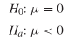
One Sided
- Fill in the matrix below with the correct responses

 |  |  |  | Truth about the population (Reality)
 |  |  | H_{o} True |  | H_{o} is False
Decision based on sample (Conclusion) |  | Fail to Reject H_{o} | Correct Decision |  | Type II Error
 |  | Reject H_{o} | Type I Error |  | Correct Decision

- Define the level of significance in a hypothesis test? With which Greek letter is it denoted?
The level of significance is a number to determine if the P-value is small enough to reject the null hypothesis. It is denoted with the Greek letter alpha (α). It is the probability of making a Type I Error.
- Write down the formula for computing the test statistic for the hypothesis test for a single mean when sigma is known.
$z= \frac{\overline{x}- µ}{\frac{σ}{\sqrt{n}}}$

- Define the P-value. How is it used in a hypothesis test?
P-value is the probability that you will observe the sample test statistic you did or one more extreme assuming the null hypothesis is true.
- If the null hypothesis is rejected in a hypothesis test, what is concluded about the alternative hypothesis?
We have sufficient evidence to conclude the alternative hypothesis is true.

- Think of a couple of examples where you have seen hypothesis testing in real life (open-ended).

(Answers may vary)

Part II: You will fill this part out during your Group Preparation session. You will do #1 and #2 with your group. Check your answers with the T.A. when you finish.

1. The Graduate Management Admission Test (GMAT) is used as an admission criterion in many masters of business administration (MBA) programs. The scores on the GMAT in the past have a mean score of 529. The BYU professor feels now that the score has improved within the last couple of years.
a. Determine the null and alternative hypotheses
Ho: µ = 529
Ha: µ > 529

b. Suppose you got evidence that the null hypothesis should be rejected. However, in reality the mean score of students taking the exam is still 529. Was a Type I or Type II error committed?
A Type I error was committed.

c. If the analysis was done at α = 0.01 level, what is the probability of committing a Type I Error?
There was about a 1 in 100 or 1% chance that there would be a Type 1 Error.

d. If we wanted to decrease the probability of making a Type II error, would we need to increase or decrease the level of significance?

Increase the level of significance.

2. A study by the National Association of Realtors reported in 2004 that second-home sales accounted for more than a third of residential real estate transactions. According to the report, the average age of a person buying a second home as an investment rental property was 47 years. Assuming the national standard deviation was 5, a real estate agent wants to determine if the average age of those buying investment property in his area is different than the national average. He randomly selects 15 of his clients who purchased an investment property and obtains the data shown.

27 | 49 | 56 | 45 | 49
35 | 55 | 50 | 46 | 48
38 | 58 | 51 | 56 | 38

a. Design the Study. What is the population from which the realtor obtains his data. How did he sample this population? What is the research question?
The researcher collects data from the population of second home buyers. It says that he randomly selects his sample from his own clients. His research question is “Is the average age of the people buying a second investment property in my area different than the national average?”

b. Collect the data. Name at least one way the realtor could have randomly selected his sample.
(Answers may vary)

c. Describe the data. Graph the data on a histogram. Sketch the histogram below or cut and paste your electronic copy. In a short paragraph describe the data by using at least five descriptive statistics.
(Answers may vary but here are the numerical and graphical descriptive statistics.)

Numerical Descriptive Statistics
Mean | 46.7333333
Standard Deviation | 8.82744638
Variance | 77.9238095
Minimum | 27
Q1 | 41.5
Median | 49
Q3 | 53
Maximum | 58
Interquartile Range (IQR) | 11.5

d. Make inference.

- Check the requirements. Since there are only 15 pieces of data, what will you need to check?
Make a QQ plot of the data to check for normality

- State the null and alternative hypothesis. (Is this a one or two-tailed test?)
Ho: µ = 47
Ha: µ ≠ 47
- Let the level of significance be α = 0.05

- Compute the test statistic. What is the formula to be used? (Recall our test statistic will be a z-score.) After writing down the general formula, input the numbers you will use. Show this work. Finally, use Excel or a calculator to compute your test statistics.

$$z_{o}=\frac{ \overline{x}- μ}{\frac{σ}{√n}}$$
z = .20910

- Compute the P-value. First, sketch a standard normal curve; graph your test statistic along the horizontal axis. Shade the appropriate area under the curve. Use the Normal Applet to compute the area under the curve. This area is the P-value.
P-value = 0.8344
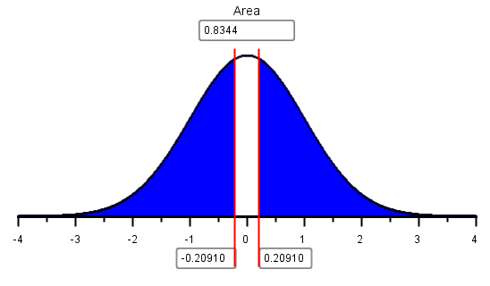

- Compare the P-value to the level of significance (the α-level). Do we reject the null hypothesis or fail to reject the null?

P-value is > level of significance ;0.8344 > 0.05 so we fail to reject the null.

- State your conclusions in terms of the alternative hypothesis
We have insufficient evidence to conclude that the mean age of people buying a second home is different in this area, than that of the national average of 47.
e. Take Action.
What action—if any—do you suggest the realtor to take based on your statistical conclusions?
(Answers may vary) I would suggest that the realtor keeps targeting that population of middle aged people as second home buyers.

